空间摄影属性：
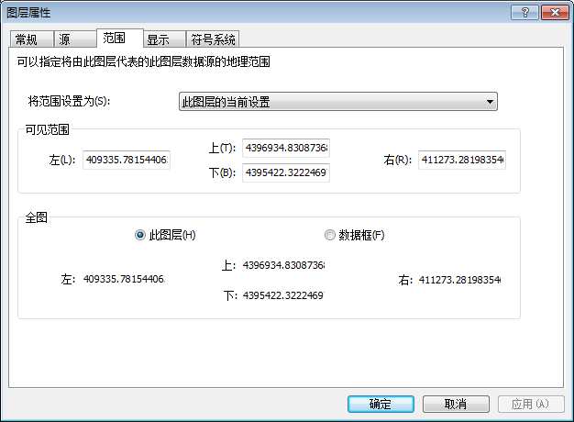
添加应用：
打开栅格：
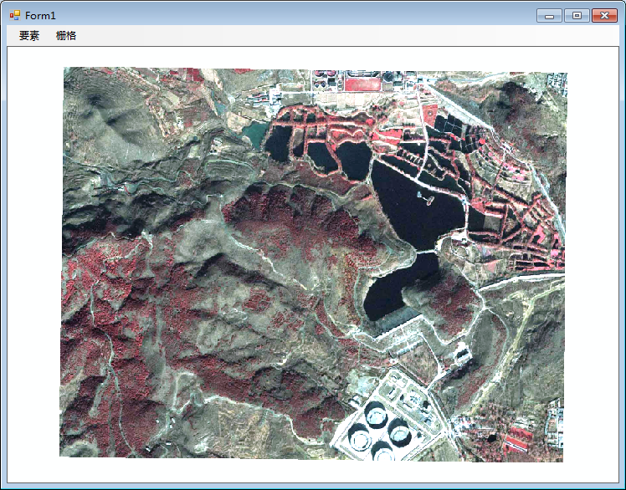
代码：
private void 打开ToolStripMenuItem1_Click(object sender, EventArgs e)
{
string Filename = "航空摄影";
IWorkspaceFactory pFact = new AccessWorkspaceFactoryClass();
IWorkspace pWorkspace = null;
string PathStr = @"E:\周口店数据\打印数据.mdb";
pWorkspace = pFact.OpenFromFile(PathStr, 0);
IRasterWorkspace2 pRasterWorkSpace;
IRasterDataset pRasterDataset;
IRasterLayer pRasterlayer=new RasterLayerClass();
pRasterWorkSpace = pWorkspace as IRasterWorkspace2;
pRasterDataset = pRasterWorkSpace.OpenRasterDataset(Filename);
pRasterlayer.CreateFromDataset(pRasterDataset);
this.axMapControl1.AddLayer(pRasterlayer);
}

取得范围：
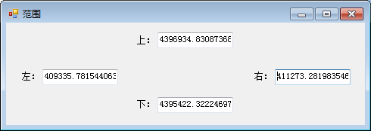
代码：
private void 获?取¨?范¤?围¡ìToolStripMenuItem1_Click(object sender, EventArgs e)
{
ILayer pLayer = this.axMapControl1.get_Layer(0);
IRasterLayer pRasterLayer = pLayer as IRasterLayer;
IEnvelope pEnvelope = ((IGeoDataset)pRasterLayer.Raster).Extent;
Form2 form2 = new Form2();
form2.textBox1.Text = pEnvelope.XMin.ToString();//左
form2.textBox2.Text = pEnvelope.XMax.ToString();//右
form2.textBox3.Text = pEnvelope.YMax.ToString();//上
form2.textBox4.Text = pEnvelope.YMin.ToString();//下
form2.Show();
}

